

GRANT APPLICATION FORM

Name of Organisation | St George’s Church
Address | Church Walk  Modbury  PL21 0QN
Registered charity number (if applicable) | X29673
Telephone Number | Richard Taylor Church Warden  01548830021  07799626134
E-mail | r3t1.taylor@btinternet.com
Contact name and position in organisation (plus address if different from above) | Richard Taylor, Church Warden  8 Stones Close  Modbury, PL21 0RZ
Account details for payment of grant | Account Number:17645168  Sort Code:30-94-72  Account Name: PCC Modbury  Name of Bank: Lloyds Bank
Describe the overall aim of your organisation and the activities or services it provides | Modbury Parish Church  To serve the community of Modbury
Tell us what you will do with the money you are requesting. | Fix a safety platform with safety rails and access ladder above the bells in the tower. This will allow safe access to a working platform to allow the Town Clock to be serviced annually.  Without this safety measure Smith of Derby are not prepared to undertake this annual service
Amount Requested  Total Cost of Project  How is the balance of the cost being funded? | £434.25  Material costs as per attached email (net of VAT £493.49) + Labour (3 x 5hrs x £25, £375)  Total £868 .49  From own funds
Signed | 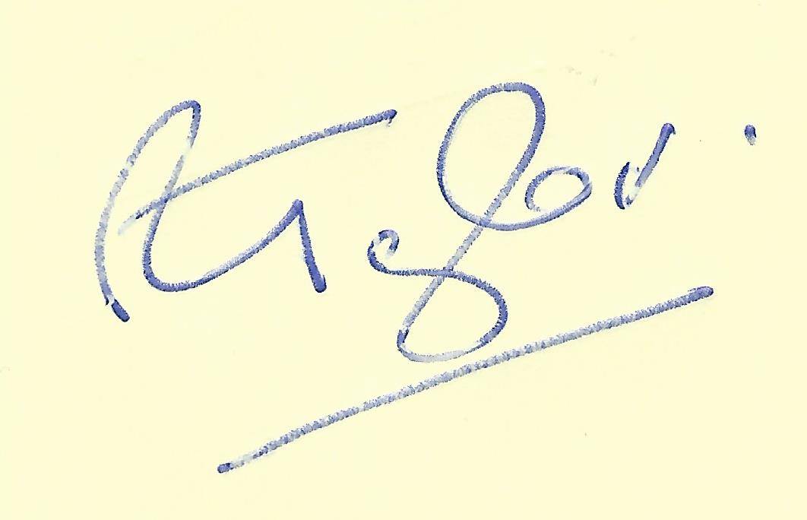
Date | 08.07.2025
Position in Organisation | Church Warden

Thank you for applying for a grant from Modbury Parish Council. Please email your completed form to: parishclerk@modburyparishcouncil.gov.uk and we will be in touch.

