

DRAFT

COMMUNITY EMERGENCY PLAN

1 September 2026

V1.1

Introduction

Modbury Parish Council (MPC) has developed this plan to provide community resilience in the pre-event phase or early stages of an emergency.

The MPC Community Response Team has been formed to assist both the activation of this plan and the community volunteers, wherever possible prior to, during and after an emergency.

The aim of this plan is to increase community resilience through developing a robust coordinated approach that complements the work of the emergency services.

The objectives of this plan are to:

- Identify the persons who will be responsible for maintaining and implementing the plan - the Community Response Team
- Identify the people who will support the Community Response Team and liaise with individual residents during an emergency
- Identify risks to the community
- Identify strategies to reduce and respond to an emergency, including warning the community
- Identify vulnerable people within the community
- Identify community resources available during an emergency
- Provide contact details for the emergency services and local authorities
- Provide information and assistance to the emergency services when they arrive and throughout the event

Community Response Team

A Community Response Team (CRT) has been set up to manage the community’s response to an emergency and keep the plan up to date. The details can be found at Annex A.

2.1 Responsibilities

The role of the Community Response Team Coordinator is to:

- Write and organise the Community Emergency Plan
- Regularly review and update the plan
- Report annually to the community telling them if the plan has been activated and if any members have changed
- Be a focal point for the community
- Maintain communication and be the main contact for local authorities and the emergency services
- Tell the appropriate authorities and individuals
- Communicate important messages to the community
- Involve all CRT members in the planning and response process, and give them tasks
- Activate resources when needed

The Deputy Community Response Team Coordinator will:

- Assist the Coordinator in undertaking the above tasks
- Activate the plan and mobilize community resources in the absence of the Coordinator

All other members of the Community Response Team should:

- Live in the community
- Have good local knowledge
- Have the support and speak on behalf of the community
- Provide vulnerable people with additional support
- Maintain communications within the community and with local authorities
- Check confidentiality is maintained where needed
- Maintain his/her own action log
- Create a ‘grab bag’ containing the plan and any suitable clothing/equipment which may be needed
- Support the coordinator and deputy in their tasks

Community Emergency Volunteers

The CRT will be supported by a network of community volunteers who will act as the link between it and each of the neighbourhoods which make up the town and parish of Modbury. They will also provide practical assistance during an emergency. Contact details for each volunteer is attached at Annex B.

3.1 Responsibilities

The role of the Community Emergency Volunteer is to:

- Support the CRT in responding to emergencies
- Act as an information conduit between the CRT and local residents and business owners
- Be aware of those members of the community who are vulnerable and may need extra support and help deliver that support
- Staff and run the Council’s Community Shelter

Identifying the risks

A risk assessment has been undertaken and the main potential emergency scenarios are seen to be as follows:

Risk | Potential impact
Storm damage | Buildings damaged such that they are no longer safe and/or habitable and residents have to be relocated. Communications disrupted and access roads blocked.
Heavy rain | Shops and homes flooded, people made homeless, utilities and communication channels compromised
Heavy snow and/or ice | Snow drifts blocking lanes and access into the town. Slipping hazard affecting vulnerable people. Inability to get to the shops or for deliveries to be made.
Major property fire | May require evacuation, temporary accommodation, liaison with gas and electricity suppliers.
Wildfire | May require emergency evacuation from multiple properties to preserve life
Major road traffic accident | May cause serious congestion to, from and around Modbury with subsequent impact for the emergency services. Residents may be unable to get to work or to shops. Temporary evacuation of drivers caught up in the congestion may be necessary.
Land slip | May damage properties requiring evacuation of occupants and may block roads causing access problems and prolonged transport dislocation
Prolonged electricity outage | Residents left without lighting or heating. Vulnerable residents may need relocating temporarily
Prolonged water outage | Residents left without drinking water and may require supplies of bottled water.
Gas leak and/or explosion | Residents may need to be temporarily evacuated and may need longer term rehousing. May also cause transport dislocation
War and civil strife | Government advice is warning of the potential disruption to energy supplies and food distribution from low-level enemy state action and/or civil strife

Maps of the community, including key buildings etc. are listed in Annex C.

Activating the plan

5.1 Triggers

This plan will be triggered either by contact from individual parishioners or from the emergency services following an unforeseen incident or in response to the announcement by the Meterological Office of an amber or red warning of extreme weather affecting the Modbury area.

5.2 Notification

It is likely that notification will be received by either the CRT Coordinator as First Responder, or in their absence, by any other members of the CRT.

For guidance on the activation procedure, see Annex D. This procedure lists the call out order and logging of actions.

The recipient will pass on notification of the emergency to the CRT and the Community Volunteers using a telephone tree notification system, see Annex E.

Taking control and managing the incident

6.1 Incident coordination

The CRT will locate to an Incident Control Point (ICP) for the duration of the emergency. They are:

Primary ICP: Modbury Parish Office, 1 Modbury Court, Church St, Modbury PL21 0CR

Secondary ICP: Modbury Memorial Hall, Back St, Modbury PL21 0RF

ICP equipment: An emergency pack - ready to use - is located in the Parish Office. The contents of the pack are listed at Annex F and should be checked regularly.

6.2 Incident handover

When the emergency services arrive they may choose a different ICP and the CRT should be prepared to relocate to it if practical.

The CRT Coordinator should introduce themselves, give them a copy of the Community Emergency Plan, and provide local knowledge and a situation report, see Annex G.

Skills and resources

7.1 Resources

For community resources available during an emergency, see Annex H.

7.2 Contacts lists

For contact details of key organisations and groups which are publicly available e.g. emergency services, health organisations, town/parish councils, local authorities, utility companies, the Environment Agency, schools etc., see Annex I

Key facilities

8.1 Community Shelter(s)

If people need to leave their homes, the emergency planning authority, will open a rest centre.

If the local authority cannot provide immediate assistance, a Community Shelter (CS) will provide a short-term refuge.

MPC Community Shelters:

Primary CS: Modbury Memorial Hall, Back St, Modbury PL21 0RF

Secondary CS: QE2 Pavilion, Recreation Ground, Chatwell Lane, Modbury PL21 0FS

Key holder and staffing arrangements are attached at Annex J.

An information sheet for evacuees is attached at Annex K.

Helicopter Landing Sites

Helicopter Landing Sites (HLS) will only be used by emergency services in the rescue phase of an emergency.

Areas for suitable Helicopter Landing Sites:

Primary HLS: QE2 Playing Fields, Chatwell Lane, Modbury PL21 0FS

Secondary HLS: Lower Poundwell Car Park, Poundwell St, Modbury PL21 0QJ

Keeping in touch

Communications

Routine contact between members of the CRT will be via emails and a WhatsApp Group.

During an emergency mobile phone contact is the preferred route of communication unless there are problems with mobile phone reception. In such an instance the Council’s hand-held radios may be used although their range is restricted to the town of Modbury only.

Warning and informing

For warning and informing methods, see Annex L.

Plan maintenance

The CRT should meet every six months to discuss community resilience arrangements and every year to review the plan and check contact numbers are correct.

The CRT should also carry out periodic emergency planning exercises to test out processes and to help train all volunteers.

When sending out updated pages of the plan it is important to ensure the old pages are replaced and destroyed. For a distribution list, see Annex M.

Modbury Parish Council
PS/V1.1/01.09.2026

Annex A - Community Response Team membership

Role | Name | Telephone | Email Address
Coordinator/ First Responder | Cllr Phil Smith | 07759  282404 | philsmith@modburyparishcouncil.gov.uk
Deputy/ Second Responder | Cllr Tony Price | 07801  837129 | tonyprice@modburyparishcouncil.gov.uk
Council Chair | Cllr Barbara  Price | 07739  752095 | barbaraprice@modburyparishcouncil.gov.uk
Team member | Cllr Sarah  Wyatt | 07794  662903 | sarahwyatt@modburyparishcouncil.gov.uk
Team Member | Cllr Ann Turner | 07542  044888 | annturner@modburyparishcouncil.gov.uk
Road and Snow Warden | Cllr Bill Cole | 01548  830913 | barbarapearncole@hotmail.co.uk

Annex B - Community Emergency Volunteers

Neighbourhood | Name | Telephone | Email Address
1. Broad St, Burns Lane, New Rd | Bob Bryant | 01548 830764
2. Poundwell, Bunkers Hill and Church Lane | Fred Davies | 01548 830915
3. Galpin St, St Georges Close, Scalders Lane | Peter Watts | 07721 918129
4. Wakehams Close, Stones Close, Traine Terrace | Cllr Sarah Wyatt | 07794  662903 | sarahwyatt@modburyparishcouncil.gov.uk
5. Church St, Church Walk, Moon Lane | Kay Freeman | 01548  830715
6. Palm Cross Green, Benedict Way, The Priory | Peter Lowe | 07930 402845 | peterjhlowe@gmail.com
7. Palm Cross estate | Cllr Chris Field  Nigel  Lee | 07836 592854  07710  319710 | chrisfield@modburyparishcouncil.gov.uk
8. Brownston St, Back St | Rob West | 07817 632058 | rob@robwest.me.uk
9. Silverwell Park, Old Traine, Ayleston Park, Tuckers Brook | Gerry  McAllister  Graham Bennett | 07957  597217  07429 237337 | gerry.mcallister@outlook.com  gfhbennettr@btinternet.com
10. Dark Lane, Treveor Gardens, Traine Villas, Oakwood Drive, Cromwell Park | Barry Keel  Tim Farrell | 07795 533704  07947  246441 | barry.keel@hotmail.co.uk
11. Champerno-wne
12. Barracks Rd, Long Park | Margaret Middleton |  | margaretm1059@gmail.com
13. Trehele | James Tall  Angie Tall | 07967  258318  07484  620365
14. Shearlangst-one
15. Brownston

Annex C - Maps of Modbury Parish and Town

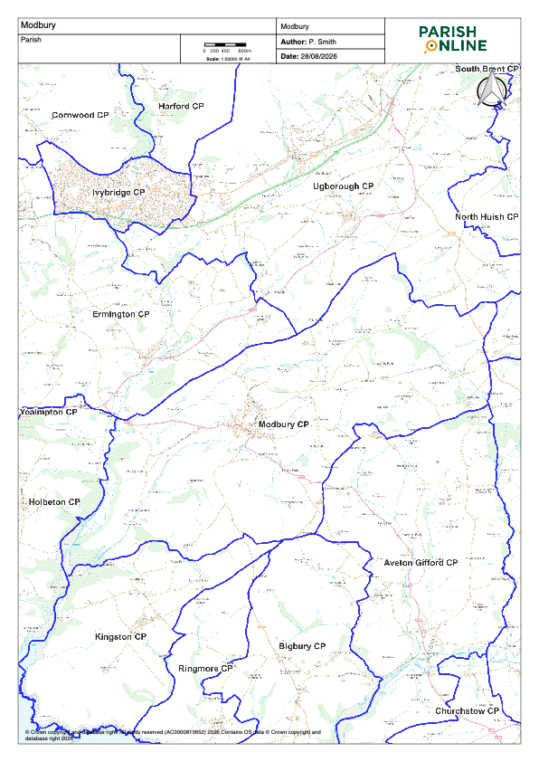
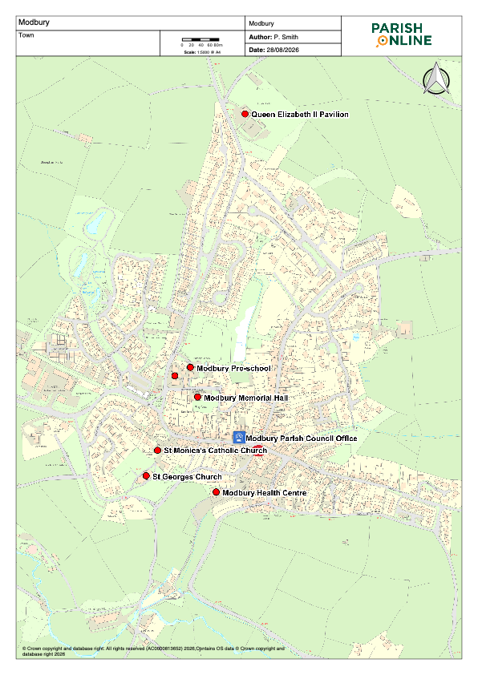

Annex D - Activation process and log sheet

Number | Action | Complete
1 | If an emergency is possible or anticipated, monitor the situation and contact CRT members and warn the community. Be prepared to respond urgently.
2 | Dial 999 and ensure the emergency services are aware of the emergency and follow any advice given.
3 | Contact and inform your district/county council.
4 | Record details on the log sheet on the other side of this page. Include:  • Decisions you have made and why  • Actions taken  • Who you spoke to and what you said  (Include contact numbers)  • Information received
5 | Contact other CRT members and the community emergency volunteers by the agreed method.  • Households affected  • Parish council/ward via the parish clerk  • Volunteers and key holders
6 | If needed, call a community meeting. Ensure the venue is safe and people can get there safely
7 | Take notes and record actions. If you decide to activate the plan, remember to follow the check sheet.
8 | When the emergency services arrive, the CRT Coordinator should introduce themselves and give them a copy of the plan.

Log sheet

Record all information during an emergency. A log sheet is an easy way to ensure information is not lost and can help support/justify any decisions made or actions taken.

Date | Time | Information / Decision / Action | Initials

Annex E – Telephone tree notification system

A telephone tree is a group of people organised as a pyramid so that they can quickly and easily spread information. The coordinator at the top calls two people, who each call one or two more people until everyone in the list has been called. If someone is not available, the next person in the tree is called.

Community Emergency Coordinator
07759 282404

MPC
Chair
07739 752095
Deputy
Coordinator
07801 837129

Cllr Chris Field
07836 592854

Cllr Bill Cole
01548 830913
Cllr Ann Turner
07542 044888
Cllr Sarah Watt
07794 662903

Area 4
Contact
number
Area 2
Contact
Number

Area 1
Contact
number
Area 7
Contact
number
Area 8
Contact
number
Area 5
Contact
number
Area 6
Contact
number
Area 3
Contact
number

AN Other
Contact
Number
Area 15
Contact
Number
Area 14
Contact
Number
Area 13
Contact
Number
Area 12
Contact
Number
Area 11
Contact
Number
Area 10
Contact
Number
Area 9
Contact
Number

Annex F - Emergency Pack contents

Items | Numbers
Contact list for emergency first aiders and siting of defribrillators

Torch | 2
Space blankets for hypothermia | 5
First aid Kit | 1
Military grade emergency bandage | 1
Face masks | 10
Gloves (disposable) | 2 boxes medium and large
Hi Viz vests | 3
Radio walkie talkie | 4 sets - 8 radios
Loudhailer | 1

Annex G – Situation report (SITREP)

Use this form to record information about an emergency and give it to emergency responders. when they arrive.

Situation report
E | Exact location of the emergency
T | Type of emergency
H | Hazards present or suspected
A | Access – routes that are safe to use
N | Number, type and severity of casualties
E | Emergency services present?

Date:
Time:
Location:
Attendees:

Current situation?

Location of emergency. Is it near:
A school?
A vulnerable area?
A main access route?

Type of emergency:
Is there a threat to life?
Has electricity, gas or water been affected?

Are there any vulnerable people involved?
Elderly
Families with children

Resources needed? Food?
Off-road vehicles?
Blankets?
Shelter?

Establishing contact with the emergency services

How can we support the emergency services?

What agreed actions can safely be taken?

Agreed actions and leads?

Any other issues?

Annex H - Community resources

Resource | Location | Contact
High Vis jackets/vests | Parish Office | Parish Clerk
Metal safety ladder | MPC Palm Cross Store | Parish Clerk
Spades/shovels/brooms | MPC Palm Cross Store | Parish Clerk
Wheelbarrows | MPC Palm Cross Store | Parish Clerk
Power strimmer/brushcutter | MPC Palm Cross Store | P3 Coordinator
Chainsaws | Trehele Farm | James Tall
Wood chipper | Trehele Farm | James Tall
Warning cones | MPC Palm Cross Store | Road Warden
Road signage | MPC Palm Cross Store | Road Warden
Sand bags | MPC Palm Cross Store | Flood Warden
Road salt/grit | MPC Palm Cross Store | Snow Warden
Tractors/trailers | Trehele Farm | James Tall
4 wheel vehicles | Wakehams Plant Hire
Telehandler | Wakehams Plant Hire
Mechanical digger | Trehele Farm | James Tall
Temporary accommodation | The Exeter Inn
Temporary accommodation and Assembly Room | The White Hart Hotel | 01548 830652
Primary Health Care | Modbury Health Centre | 01548 830666
 | Modbury Pharmacy | 01548 830215
Faith support | St Georges Church | Church Warden
 | St Monica’s Catholic Church | 01752 895888
Elected representatives | South Hams DC | Cllr Bernard Taylor  01548 830844
 | Devon CC | Cllr Louise Wainwright

Annex I - Key contact list

Category | Service/Name | Telephone Number | Additional Information
Emergency Services | Police | Emergency: 999  Non Emergency: 101
 | Fire | Emergency: 999  Office: 01392 872200 | Fire/Flood Rescue,  Support/Resources
 | Ambulance | Emergency: 999  General: 01392 261621
 | Coastguard | Emergency: 999  General: 0870 600 6505 | Water Rescue  Resources/Support
Activation and Emergency Planning | Devon County  Council | 0845 155 1020 | General enquiries
Flooding and Forecasting | Environment Agency Flooding | 0345 988 1188 | Report flooding. Seek advice regarding flood warnings and what to do before/during/after a flood
 | Environment Agency | 08708 506506 | General enquiries
 | Met Office | 0870 900 0100 | Meteorological forecasting
 | Met Office Weathercall | 09014 722054
Utilities | South West Water | 0800 169 1144 | Non-domestic water leaks
 | National Grid | Office: 0845 601 2989 Silent: 0800 365900 | Power cuts
 | British Gas | 0800 111999 | Gas leaks
 | National Gas | 0800 169 1144 | Gas leaks
 | BT | 01525 290647  0800 800150 | Telecommunications
Healthcare | Modbury Health Centre | 01548 830666 | Medical/Healthcare
 | NHS Direct | 0845 4647  (until February 2014) | Advice
 | South Hams Hospital |  | Medical/Healthcare
Derriford
Hospital
Highways | Devon County Council Highways | 01392 383329 | Highways management
 | Highways Agency | 08457 504030 | Highways Information Line
Vehicle recovery
Schools | Modbury Primary School | 01548 830312
 | Ivybridge Community College
District Council | South Hams DC
Local Media | BBC Radio Devon | News: 01752 234511  Travel: 0845 300 2829  On air: 0845 301 1034  Plym’th: 01752 260323  Exeter: 01392 215651 | Media, warning and informing
Animal Welfare | RSPCA | 24 hour: 0300 123 4999  Office: 0300 123 4555
Emotional Support Services | Samaritans 24hrs | 0845 303 0900 | 24hr telephone support
 | Victim Support 0800-2000 | 0845 676 1020 | Support

Annex J - Community Shelter key holders, failities and staffing

Venue | Keyholder | Facilities
Modbury Memorial Hall | Pauline Ryder  07920 760146 | Large hall, stage, side room, kitchen, toilets, heating, gas, electricity, disabled access, parking
QE2 Pavilion | Paul Romney  07971 662944 | Large room, separate changing rooms and showers, toilets, kitchen, gas, electricity, heating, disable access, parking

Proposed staffing arrangements:

Position | Name | Responsibilities
Community Shelter Coordinator | Margaret Middleton | Manage shelter.  Provide feedback to CRT Coordinator
Receptionist 1 |  | Staff a reception desk  Maintain a register of those in attendance.
Receptionist 2 |  | As above
Volunteer First Aider | Naomi Ainsley | Provide basic first aid as required
Volunteer Cook |  | Provide snacks/meals as required
Volunteer Evacuation Assistant |  | Assist evacuees, provide comfort  Issue blankets etc

Annex K - Evacuee information sheet

Please read this sheet as it contains information you will need about the Community Shelter (CS).

Registration
Please register at the reception desk. You don’t have to register, but it is recommended, as it helps staff if any of your relatives are looking for you. Registration information is confidential.

Smoking and alcohol
Smoking and the consumption of alcohol is not permitted in the CS.

Personal belongings and children
We cannot assume responsibility for your belongings. Please keep valuable items with you. Parents are responsible for keeping track of and controlling their children. Please don’t leave them unattended.

Medical and injuries
If you have a medical condition that needs special consideration, i.e., heart condition, recent surgery, or pregnancy, please tell the staff. All medical information will be written on your registration card and is confidential.

Pets
We understand pets are part of your family. Unfortunately our shelter may not be suitable for them. Tell us about your pets and we can help locate a temporary home for them where they will be well looked after. Registered Guide/Hearing Dogs are allowed within the CS.

Bulletin boards
Updates and bulletins will be put on a notice board for your information.

Volunteering and help
Evacuees are encouraged to help in the CS. Speak to the staff if you can help.

Telephones
We encourage you to tell a family member or friend where you are and ask them to tell others that may be worried about you. Please be considerate when using a mobile phone by speaking quietly.

Community Shelter(s) coordinator
Please listen to the coordinator and staff. They are the officials in the CS.

Problems and complaints
Please direct all comments about the CS operation to the coordinator.

News/media
News/media often visit the CS during an emergency. They may request interviews or photographs; however, they must ask your permission first. It is your right to refuse. Please report any problems or questions about the media to the coordinator.

Special needs/requirements
If you have any special needs, i.e. diet, health etc., please let the staff know.

If you require further information please ask any of the staff.

Annex L - Communication of warnings and advice to the community

Social Media | Media
Nextdoor Modbury | spotlight@bbc.co.uk
Facebook-Modbury Community Group | Telephone: 01752 234511. E-mail: radio.devon@bbc.co.uk.
Facebook-Bloor Homes Modbury | Heart: 0333 200 2000
Facebook-Modbury Parish Council | Pirate FM On Air Studio: 01209 313900
Instagram-Modbury Parish Council
WWW.modburyparishcouncil.gov.uk

Annex M - Distribution list

